Chapter 8 – Health and Safety

Fact-sheet – How to ensure medical care at the workplace?

What is the objective?

Emergency situations may arise in the factory premises due to factors such as heat, noise, dust, hazardous chemicals, unsafe machines, etc. Primary medical care can help to avoid permanent damage.

To ensure proper medical care, the factory should first be aware of the incidents that may happen in the premises and take necessary actions accordingly:

- Map the possible emergencies that may occur in the workplace and occupational disease to control ;

- Ensure medical practitioner (doctor, nurse) in the premises as prescribed in law, or at least to have trained first aiders in premises (if no legal requirement) ;

- Availability of medical supplies (medicine, first aid kits, etc.) as per local law or at least the kits required for first aid (if no legal requirement) ;

- Train key workers (first aiders) to provide first aid and train all workers on the availability of medical care at the premises ;

- Agree with a nearby hospital to provide emergency medical care to workers, if needed;

- Conduct regular internal inspections to ensure medical care measures are effectively maintained on site.

Chapter 8 – Health and Safety

Fact-sheet – How to ensure medical care at the workplace?

How to achieve the objective?

- How to ensure medical care at the workplace?
• Map the possible emergency situations that may occur in the workplace and occupational disease to control ;

• Ensure the knowledge of primary aid needed for such situations are available (for example: first aid leaflet, trainer, etc.) ;

• Appoint responsible person to ensure resources, expertise and training needed for
Step 0 | medical care ;  • Develop an action plan with above elements.

• Establishment of a medical center in the premises, if it is not required by law, then at least have a dedicated room ;

• Availability of first aid kits / required medical supplies in the medical center and/or production floors ;

• Regular verification of the status of medical supplies and ensure they are not
Step 1 | expired and in good condition ;
 | • Maintain a check list with each first aid box, mentioning date of check, kits
 | available in the box, and the person responsible of the box.

• Appoint medical practitioner (doctor, nurse) in the premises as prescribed in law, or
at least to have trained first aiders in the premises (if no legal requirement) , who will ensure the following:

• Smooth functioning of medical center in the premises ;

• Create a standard level of medical care center and ensure preventive and curative treatment ;

Step 2 • Maintain proper record keeping systems ;

• Conduct training sessions on First aid to key workers (first aiders), to all workers on health & safety, hygienic issue and create awareness about accident & sickness.

• Agree with a nearby hospital to provide emergency medical care to workers, if
needed ;
• Ensure emergency numbers (healthcare facilities, ambulance service etc) are
posted in visible areas and are easily accessible ;
• Provide all workers with Occupational Health checkups according to local law,
before, during and after employment.
Step 3

Fact-sheet – How to ensure medical care at the workplace?
Chapter 8 – Health and Safety

Common non-compliances

Non-compliance | Comment

No person available to ensure care
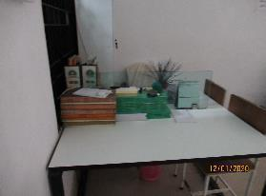

Absence of resource persons (medical assistant, doctor, first aider) in the medical center and nobody to cater for the medical needs of the workers even if it is required by law.

Insufficient first aid kit
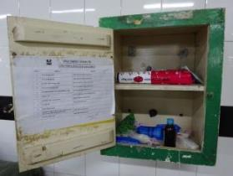

First aid box found with insufficient first aid kit (referred by law or posted list).

Inability to provide first aid due to the shortage of supplies.

Expired medicine
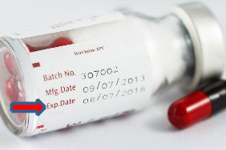

Medicine in the first aid box found expired.

May cause a major health risk due to toxicity and ineffectiveness in actual injury.

Good practices

  - Arrange medical specialists to conduct periodical health camps (mobile programs of preventive health check and awareness training sessions around health and hygiene organized by NGOs, hospitals, or other local medical structures).

  - Organize regular health check-ups of all the workers even if it is not required by the law.

  - If the law does not require appointing a doctor in the premises, appoint a doctor/nurse for worker’s benefit.

  - If the factory is far away from the nearest medical center, then ensure an in-house medical center with amenities like- operation theatre, pathological lab, surgeons, etc.

  - Perform daily inspections of first aid boxes to ensure all the kits are available and medicines are not expired.

